Name: Ms. Linda Mary John
Qualification: BE(Information Technolgy),
ME(Computer Engineering)
Experience: 4 years
Achievements:
Awards:
Paper Published:
1] Books:
2] National Journal:
3] International Conference: 5
4] International Journal:
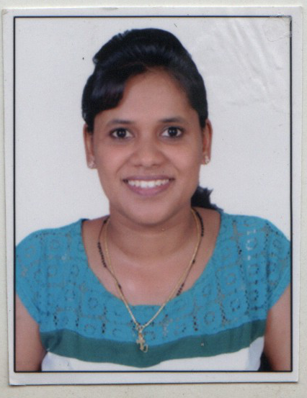
Photo:

